Contact Us:
Email Emily at:
brethrenbugle@gmail.com
Follow us on Twitter:
@michigancob
Find us on Facebook
Michigan District Church of the Brethren
Important Links:
www.michigancob.org
www.brethren.org
Page 1

The Brethren Bugle
January 2016
  - Michigan District Church of the Brethren Monthly Newsletter
Emily Woodruff

Hello and Happy New Year Michigan Brethren!
I hope this Bugle reaches you well. If there are others in your church who are interested in receiving this newsletter, please send me their information and they will be added to the mailing list.
Letter from the Editor

In the new year, the Brethren Bugle will be taking on some changes. Please anticipate it’s arrival in your inbox bi-monthly. With this change, I will be spending more of my hours working in the district office attempting to tackle more administrative tasks.
In other news, the Michigan District would like to acknowledge Joe Wave and his service of over a decade at Marilla Church of the Brethren. As of January 1, 2016 he has moved into retirement. With this, Frances Townsend is now pastoring both Onekama Church of the Brethren and Marilla Church of the Brethren. We thank them both for their service to our district!
As a result from your responses at District Conference 2015, we will be exploring a new location for our upcoming meeting this summer. Mark your calendars for District Conference- August 19 & 20 at New Haven Church of the Brethren! We are excited to see what’s in store for us this year. There will be great speakers and musicians, childcare, workshops and fundraisers for you to look forward to! More information will come as we approach this date.
Please check out the letters and flyers below, as they are filled with ways for you and your church to connect with others in our district. The very last bit of the Brethren Bugle has our District’s 2016 calendar laid out. If you have additional events that you would like featured here, please do not hesitate to e-mail me your even information and I will gladly share this in our newsletters!
Finally, please join me in celebration of these recent baptisms and new memberships in our district:
The Church in Drive baptizes 4: Katie Moon, Levi Goodwin, Mariah Jenkins, and Megan Takacs! All four are either regular church attendees or regular in attendance at SVSU’s chapter of Standing in the Gap.
Common Spirit welcomed three new members in November: Amy and Cyprian Gardine and Scot Miller

-Emily Woodruff
Letter from the Moderator
Michigan District Church of the Brethren

2016 Theme for District Conference

The theme of the 2016 Michigan Church of the Brethren District Conference (August 19 and 20, 2016) is “Putting our faith into practice.” I think one of the greatest tests of our faith is the manner in which we relate to other believers (and non-believers as well). Living in our world with exposure to many sources of influence may nudge us toward greater polarity rather than greater community. We are often insulated from those with whom we need to interact due to distance, sometimes few common interests, and seemingly, desire. Expressing a common witness to the saving grace of Christ is compromised through the struggle of insisting on the correctness of our own interpretation of scripture (and opinions). This year’s theme will focus on how we can be Christ-like as we show Christ’s compassion through our interaction with others.
Relevant scriptures are “As a prisoner for the Lord, then, I urge you to live a life worthy of the calling you have received. Be completely humble and gentle; be patient, bearing with one another in love. Make every effort to keep the unity of the Spirit through the bond of peace. There is one body and one Spirit
--just as you are called to one hope when you were called—one Lord, one faith, one baptism; one God and Father of all, who is over all and through all in all,” Ephesians 4:1-6 and “And let us consider how we may spur one another on toward love and good deeds. Let us not give up meeting together, as some are in habit of doing, but let us encourage one another—and all the more as you see the Day approaching,” Hebrews 10:24 and 25.

Frank Polzin
2016 Michigan District Moderator

Sisters and Brothers in Christ,
The Leadership Team has received a letter signed by a few congregations that calls into question the actions of other congregations within the Michigan District. The Leadership Team hears the concerns of those congregations. While the Leadership Team does not have the authority to instruct any congregation on how to carry out their mission, our consensus is that it would be inappropriate to censure them for following their faith and convictions. The Leadership Team does call on congregations to be sensitive to how their actions reflect on the wider church here in Michigan and across the denomination. We urge all congregations to be creative in how they follow their faith and mission, especially in potentially controversial situations, such that they are seen to be representing their own congregations but not necessarily the Church of the Brethren as a whole.
After a lengthy executive closed session the Leadership Team unanimously passed the following motion: “that we send a letter back to the three churches thanking them for their letter and concern and also publish a letter encouraging all congregations to be sensitive and creative in ways to carry out their mission while being mindful that not all of the COB is in the same place and recommend that all consider the 2008 Annual Conference statement, “Resolution Urging Forbearance,” and that it is not appropriate or helpful to the building up of the unity of the body to use the COB name in controversial issues.”
The Leadership Team is well aware that the Michigan District is not of one mind on many issues. Even some issues that we consider core to our faith and practices reflect a spectrum of beliefs and theology. We call all of our congregations to revisit and study the 2008 Annual Conference statement, Resolution Urging Forbearance. This paper states, in part, “Among us are Brethren who keep us true to the word, the law, and our traditions because God has spoken so powerfully there. Among us also are those who seek new light because God is still working and doing new things. The Bible holds both “keepers” and “seekers” in high regard. Jesus embodied both realities in his life and teachings.” The Michigan District also holds both “keepers” and “seekers” in high regard and we encourage all Brethren to always remember that we are all God’s children and that we are all seeking to continue the work of Jesus, peacefully, simply, together.
We can be instructed by the 1979 Annual Conference paper on Biblical Inspiration and Authority which states, “It is the love experienced when Christ is at the center of one's life, that draws us into unity. We do not create unity or fellowship. They are gifts. When our lives are Christcentered, we can disagree without being bitter or divisive. It is a mark of the working of the Holy Spirit that we can hold one another in love and fellowship even though there is diversity among us.
Christian love requires:
● that we acknowledge the integrity and worth of those brothers and sisters with whom we cannot totally agree.
● that we make every effort to understand one another by keeping lines of communication open, by listening to, hearing, and responding to our sisters/brothers.
● that we be willing to test our perceptions and understandings with the gathered church.
● that we be open to the counsel of our brothers and sisters.
● that we behave in ways that build up the church.
● that we be obedient to Jesus Christ.
● that we not attempt to gloss over our differences, but that we face them honestly and work at resolving them "with patience, forbearing one another in love, eager to maintain the unity of the Spirit in the bond of peace" (Eph. 4:23).
● that we hold before us the goal of "being in full accord and of one mind" (Phil. 2:2).”
The Michigan District Leadership Team prays for and earnestly desires that we all be united in our love for Christ and each other. We need to be mindful of the emotional as well as the spiritual wellbeing of our Sisters and Brothers and take care that we do not cause undue strife within the District. We are reminded that all congregations of the Michigan District are doing their best to carry out their mission and witness faithfully according to their discernment of God’s call to them. We will not all agree on how to realize that call but we should all uphold each other and forbear with each other in our efforts to do so.
-The Leadership Team of the Michigan District of the Church of the Brethren

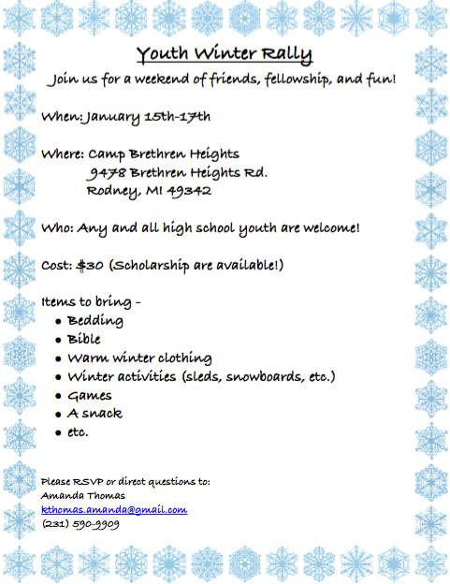
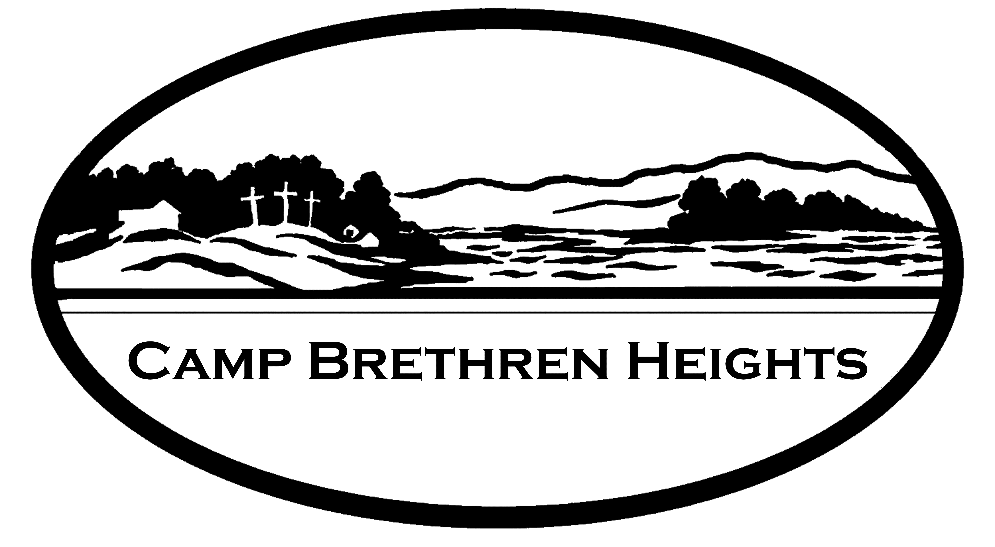
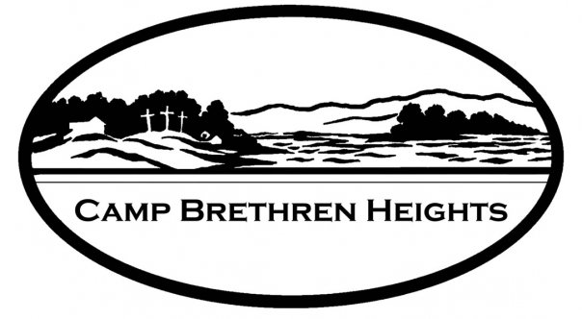
9478 Brethren Heights Rd • Rodney, MI 49342

(231) 867-3618 • brethrenheights@gmail.com
www.campbrethrenheightsmi.org

Connect with Creation. Cultivate Community. Develop Disciples.

December 12, 2015
Greetings from Camp Brethren Heights,

Traditionally, this time of year is a quieter one along the shores of Jehnsen Lake but we are already looking ahead to the summer of 2016. Looking back at on our seasons of ministry we have much to be grateful for. We saw our campership participation higher than its been in nearly a decade.
We were blessed this summer with a dedicated group of deans, counselors, staff and CiT’s. They truly were core to the success of our summer camp programs and our ministry would not happen if it weren’t for these committed folks helping to bear witness to God’s love through Jesus. It was evident from the opening campfires to closing circles that they care deeply about helping children and youth grow and deepen in their faith. Lives are continuing to be changed here at Brethren Heights and we are excited about what the future holds.
We are deeply invested in the next chapter of its ministry as we have been working with various factions of the district and camp agencies. We are in the midst of expanding our summer camping programs to include more adventure and wilderness camps. We are also in the midst of fundraising to make improvements to the camps infrastructure to help ensure the future of outdoor ministry in Michigan.

- $100 provides for one camper to attend Otter Camp
- $150 will cover more than half the costs of a camper for a week of our residential camps
- $250 provides for a week of profound discovery for a young person to attend a week
- $500 can help us cover our grocery costs for nearly a week of summer camp
- Larger gifts can be designated for specific projects like building new bath houses and other facility upgrades in the capital campaign

You are a part of something that has great hope and carries deep meaning! Perhaps you have been waiting to give to Camp Brethren Heights, or maybe you just got busy with a number of other things and forgot. It’s not too late to make an investment in the future leaders of our churches and communities. Your gifts would help us meet some of our year end needs and finish the year strong.

With gratitude,
Randall Westfall
Director of Outdoor Ministry

CHURCH FINANCE
Beginning on January 1, churches having nonminister employees (or a minister who has elected voluntary withholding) should begin withholding federal income taxes according to the new tables and instructions contained in the 2016 edition of IRS Publication 15 ("Circular E"). Every church having nonminister employees should contact the IRS to obtain the 2016 edition of this important publication. You can order a copy by calling the IRS forms hotline at 1-800-829-3676. It also is available on the IRS website (irs.gov).

Thank you.

Together in ministry,
Mary Jo

Mary Jo Flory-Steury
Associate General Secretary
General Offices: 800-323-8039 ext 381
Office Phone: 847-429-4381
Cell: 847-644-1153

January
9-Program & Arrangements Meeting
10-12 Pastor Retreat
15-18 Senior High Rally
24-28 CODE Meeting
30- New Church Development & Renewal Team Meeting

February
6-Camp Brethren Heights Inc meeting
13-District Leadership Team Meeting
March
19- Program & Arrangements Meeting
31- April 2 Bethany Board Meeting

April
2-4 CODE Meeting
9- Meet the Moderator
15-16 Young Adult Theological Forum

May
7- Ministry Team Meeting
19-21 Church Planting Conference
27-30 Wolf Camp at CBH (family)

June
29-July 3 Annual Conference
16-18 Owl Camp at CBH (intergenerational)
23-26 Red Tail Hawk Camp at CBH
(Grades 10-12)
26-2 Survivor Camp @ CBH (Ages 12-14)

July
10-12 Otter Camp (grades 1-3)
10-13 Archer Camp (ages 10-14)
17-23 Beaver Camp (grades 4-6)
24-30 Bobcat Camp (grades 7-9)
31-6 Dadirri Camp (ages 15-18)
August
19-20 District Conference
October
28-30 Bethany Board Meeting

If you have an event or update you’d like listed in the Brethren Bugle, please email Emily at brethrenbugle@gmail.com with the information.

2016 Calendar of Events

