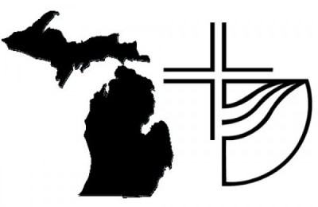 Michigan District Church of the Brethren
District Conference Delegate Registration
August 13 –14, 2021
Congregation ______________________________________________________
Number of Delegates: _____ (One delegate for each 25 members or faction thereof - for a maximum of four)
Please send this form and payment ($50 per delegate) to Mary Gault, 175 West Bidwell Street, Battle Creek, MI 49015 or send by email: marygault@yahoo.com

Name: _________________________________________
Address: __________________________________________________________
Email: _____________________________________ Phone: ________________

Name: _________________________________________
Address: __________________________________________________________
Email: _____________________________________ Phone: ________________

Name: _________________________________________
Address: __________________________________________________________
Email: _____________________________________ Phone: ________________

Name: _________________________________________
Address: __________________________________________________________
Email: _____________________________________ Phone: ________________

