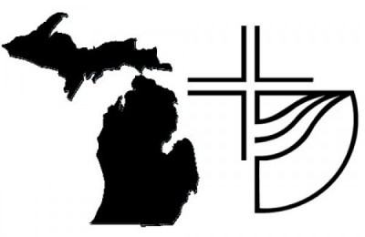 Michigan District Church of the Brethren
District Conference Delegate Registration
August 12 –13, 2022
Congregation ______________________________________________________
Number of Delegates: _____ (One delegate for each 25 members or faction thereof - for a maximum of four)
Please send this form and payment ($50 per delegate with check made to Michigan District Church of the Brethren) by August 1, 2022 to Mary Gault, 175 West Bidwell Street, Battle Creek, MI 49015 or send by email: marygault@yahoo.com. After August 1, please include a $25 late fee.

Name: _________________________________________
Address: __________________________________________________________
Email: _____________________________________ Phone: ________________

Name: _________________________________________
Address: __________________________________________________________
Email: _____________________________________ Phone: ________________

Name: _________________________________________
Address: __________________________________________________________
Email: _____________________________________ Phone: ________________

Name: _________________________________________
Address: __________________________________________________________
Email: _____________________________________ Phone: ________________

